* **Information Systems**

An information system (IS) is the study of complementary networks of hardware and software that people and organizations use to collect, filter, and process, create, and distribute data. The study bridges business and computer science using the theoretical foundations of information and computation to study various business models and related algorithmic processes within a computer science discipline.

An information system is a unique configuration of IT resources and organizational processes whereby the IT resources (and the information they provide) are applied to support specific organizational processes.

Any specific Information System aims to support operations, management and decision making. In a broad sense, the term is used to refer not only to the information and communication technology (ICT) that an organization uses, but also to the way in which people interact with this technology in support of business processes.

processes

IT resources

INFORMATION

SYSTEMS

* **Types of information systems**

The 'classic' view of Information systems found in the textbooks[[36]](http://en.wikipedia.org/wiki/Information_systems#cite_note-36) in the 1980s was of a pyramid of systems that reflected the hierarchy of the organization, usually [transaction processing systems](http://en.wikipedia.org/wiki/Transaction_processing_systems) at the bottom of the pyramid, followed by [management information systems](http://en.wikipedia.org/wiki/Management_information_systems), [decision support systems](http://en.wikipedia.org/wiki/Decision_support_systems), and ending with [executive information systems](http://en.wikipedia.org/wiki/Executive_information_systems) at the top. Although the pyramid model remains useful, since it was first formulated a number of new technologies have been developed and new categories of information systems have emerged, some of which no longer fit easily into the original pyramid model.

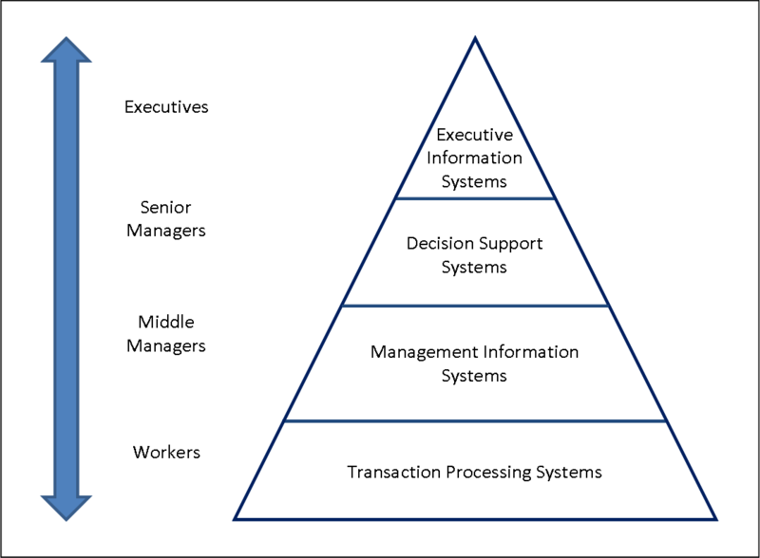

**Four-Level-Pyramid-model**

Some examples of such systems are:

* [Data Warehouses](http://en.wikipedia.org/wiki/Data_warehouses)
* [Enterprise Resource Planning](http://en.wikipedia.org/wiki/Enterprise_resource_planning)
* [Enterprise Systems](http://en.wikipedia.org/wiki/Enterprise_systems)
* [Expert Systems](http://en.wikipedia.org/wiki/Expert_systems)
* [Geographic Information System](http://en.wikipedia.org/wiki/Geographic_information_system)
* [Global Information System](http://en.wikipedia.org/wiki/Global_information_system)
* [Office Automation](http://en.wikipedia.org/wiki/Office_automation).
* **Organization**

Organization involves coordination and control mechanisms for people, process and structure.

* **Organization and Environment**

Organization and Environment includes stakeholders, competitors, and other influences on the system.

**INPUTS**

**OUTPUTS**

regulators

investors

partners

customers

suppliers

**Organization & Environment**

regulators

partners

customers

suppliers

**INPUTS**

**OUTPUTS**

*IT resources*

*information*

*systems*

**Information Systems in Organizations**

* **Major Types of Systems in Organizations**

There are various types of systems used in organizations. Some most important of those are:

1. **Executive Support Systems (ESS)**

Executive Support System (ESS) is a reporting tool ([software](http://www.webopedia.com/TERM/S/software.html)) that allows you to turn your organization's [data](http://www.webopedia.com/TERM/D/data.html) into useful summarized reports. These reports are generally used by executive level managers for quick access to reports coming from all company levels and departments such as billing, cost accounting, staffing, scheduling, and more.

1. **Decision Support Systems (DSS)**

A decision support system (DSS) is a computer-based [information system](https://en.wikipedia.org/wiki/Information_systems) that supports business or organizational [decision-making](https://en.wikipedia.org/wiki/Decision-making) activities. DSSs serve the management, operations, and planning levels of an organization and help to make decisions, which may be rapidly changing and not easily specified in advance. Decision support systems can be either fully computerized, human or a combination of both.

1. **Management Information Systems (MIS)**

A management information system (MIS) provides information that organizations require to manage themselves efficiently and effectively.[[1]](https://en.wikipedia.org/wiki/Management_information_system#cite_note-1) Management [information systems](https://en.wikipedia.org/wiki/Information_system) are typically computer systems used for managing five primary components: Hardware, Software, Data (information for decision making), Procedures (design, development and documentation) and People (individuals, groups, or organizations).

1. **Office Systems**

Over the years, Office systems have grown substantially closer with shared features such as a common spell checker, [OLE](https://en.wikipedia.org/wiki/Object_Linking_and_Embedding) data integration and Microsoft [Visual Basic for Applications](https://en.wikipedia.org/wiki/Visual_Basic_for_Applications) scripting language.

1. **Transaction Processing Systems (TPS)**

A transaction process system (TPS) is an information processing system for business transactions involving the collection, modification and retrieval of all transaction data. Characteristics of a TPS include performance, reliability and consistency. TPS is also known as transaction processing or real-time processing.

* **Traditional View of the Systems**

Within the business there are functions, each having its uses of information systems. Outside the organization’s boundaries there are customers and vendors. Functions tend to work in isolation.

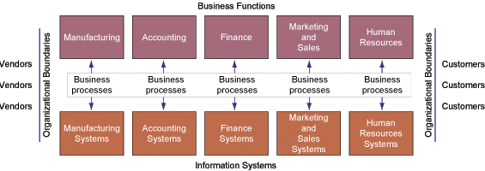

**Traditional View of the Systems**